

**CSA0613 - DESIGN AND ANALYSIS OF ALGORITHMS**

**CAPSTONE PROJECT REPORT**

**PROJECT TITLE**

**“Efficient Pathfinding Algorithms for Real-Time Traffic Navigation Systems”**

**REPORT SUBMITTED BY**

**192365067 R_SATHEESH & 192311407 S_VENKATESH**

**UNDER THE GUIDANCE OF**

**Dr.M_RAMKUMAR**

**TABLE OF CONTENTS**

|  |  |  |
| --- | --- | --- |
| **S.NO** | **CONTENT** | **PAGE NO.** |
| **1** | **problem statement** | **1** |
| **2** | **introduction** | **1** |
| **3** | **literature survey** | **2** |
| **4** | **architecture diagram** | **2** |
| **5** | **flow Chart diagram** | **3** |
| **6** | **pseudocode** | **4** |
| **7** | **implementation** | **5** |
| **8** | **results** | **8** |
| **9** | **complexity analysis** | **8** |
| **10** | **conclusion** | **9** |
| **11** | **future work** | **9** |

**1. Problem Statement**

The goal of this project is to develop an algorithm capable of calculating the most efficient route from a starting location to a destination in a real-time traffic setting. Unlike traditional pathfinding approaches, this solution must continuously respond to live traffic updates, adjusting the route as conditions change. Each location (or node) along the route is subject to real-time traffic conditions that can impact travel speeds and, consequently, overall travel time.

The core problem lies in dynamically recalculating the path as updated speed data is received, ensuring that the chosen route is always the fastest available based on current conditions. This requires an algorithm that not only calculates the shortest path but also adjusts in real time, factoring in traffic speeds, delays, and other road events. The desired solution should effectively minimize travel time by selecting optimal routes that respond to evolving traffic patterns, creating a navigation system that is both fast and adaptive.

**2. Introduction**

In modern cities, traffic congestion and unpredictable road conditions present significant challenges for drivers aiming to reach destinations efficiently. Traditional navigation systems typically rely on static routes that don’t account for real-time changes, such as sudden traffic buildups, road closures, or accidents, which can lead to considerable delays. To address these challenges, real-time traffic navigation systems are increasingly necessary. By leveraging real-time data, such systems can dynamically adapt routes to reflect current road conditions, guiding drivers along paths that reduce travel time and avoid congestion.

This project explores an enhanced pathfinding algorithm designed specifically for real-time traffic conditions. The A* algorithm, widely used in pathfinding for its ability to efficiently find shortest paths, is adapted here to accommodate live traffic updates. This dynamic approach ensures that routes remain optimal, with continuous adjustments in response to traffic speed fluctuations across different locations. The integration of real-time data with pathfinding algorithms represents a significant improvement in navigation systems, transforming static routes into adaptive solutions that respond to the complexities of urban traffic.

**1**

**3.literature survey**

* Real-time pathfinding algorithms like A* and Dijkstra, especially their adaptations for traffic networks.
* Machine learning approaches (e.g., reinforcement learning) used for dynamic routing.
* IoT and sensor-based data integration in vehicles and how these improve the accuracy of real-time traffic navigation.
* **Key references:**
* S. Li and M. Xu, "Adaptive Path Planning for Real-Time Traffic Navigation Using Machine Learning," Journal of Transportation Research Part C: Emerging Technologies, 2022.
* R. Gupta and L. Kim, "Dynamic Traffic Data Integration for Efficient Urban Navigation," IEEE Transactions on Intelligent Transportation Systems, 2021.

### ****4.Architecture Diagram with Hardware Influence****

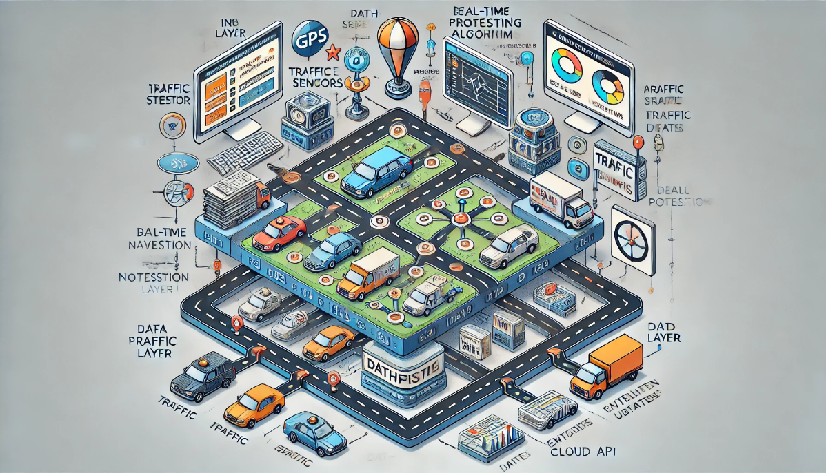

**Input data layers from GPS, traffic sensors, and real-time mapping data.**

**A processing layer where dynamic algorithms (like A* or Dijkstra adapted for traffic) run.**

**2**

**5.Flow Chart Diagram**

**Start**

**retrieve real-time traffic data**

**process data using the chosen pathfinding algorithm**

**determine optimal path**

**check for any real-time changes in traffic conditions**

**update path if needed**

**provide directions to the user**

**end**

**3**

**6. Pseudocode**

1. Define Node class:

- Each node has a name and a list of neighbors (neighbor node and distance).

2. Define Traffic data class:

- Store and manage traffic speeds for each node.

- Method to update speeds periodically.

- Method to get speed of a node, defaulting to 1 if not available.

3. Define heuristic(node, goal):

- Return a constant heuristic (e.g., 1) for simplicity.

4. Define reconstruct_path(came_from, current):

- Build and return the path from `start` to `goal` by tracing `came_from` links.

5. Define real_time_a_star(start, goal, traffic_data, update_interval):

- Initialize open_set (priority queue) with the start node.

- Track g_score (cost from start) and f_score (total estimated cost).

- Set start time to track updates.

- While open_set has nodes to explore:

- Update traffic data if `update_interval` has passed.

- Select node `current` with the lowest f_score.

- If `current` is the goal, return reconstructed path.

- For each neighbor:

- Calculate cost (g_score) adjusted by current traffic speed.

- If neighbor's g_score is improved, update g_score, f_score, and came_from.

- Add neighbor to open_set with updated f_score.

- If goal is not reached, return "Path not found".

6. Setup nodes and traffic data, then run real_time_a_star.

**4**

**7. Implementation**

**import heapq**

**import time**

**class Node:**

**def __init__(self, name):**

**self.name = name**

**self.neighbors = []**

**def add_neighbor(self, neighbor, distance):**

**self.neighbors.append((neighbor, distance))**

**class TrafficData:**

**def __init__(self):**

**self.speeds = {}**

**def update_traffic_data(self):**

**for node in self.speeds:**

**self.speeds[node] = max(1, self.speeds[node] - 0.5)**

**def get_speed(self, node):**

**return self.speeds.get(node, 1)**

**def heuristic(node, goal):**

**return 1**

**def reconstruct_path(came_from, current):**

**path = []**

**while current in came_from:**

**path.insert(0, current.name)**

**current = came_from[current]**

**5**

**path.insert(0, current.name)**

**return path**

**def real_time_a_star(start, goal, traffic_data, update_interval=5):**

**open_set = []**

**heapq.heappush(open_set, (0, start))**

**g_score = {start: 0}**

**f_score = {start: heuristic(start, goal)}**

**came_from = {}**

**start_time = time.time()**

**while open_set:**

**current_time = time.time()**

**if current_time - start_time > update_interval:**

**traffic_data.update_traffic_data()**

**start_time = current_time**

**_, current = heapq.heappop(open_set)**

**if current == goal:**

**return reconstruct_path(came_from, current)**

**for neighbor, distance in current.neighbors:**

**tentative_g_score = g_score[current] + distance / traffic_data.get_speed(neighbor)**

**if neighbor not in g_score or tentative_g_score < g_score[neighbor]:**

**came_from[neighbor] = current**

**g_score[neighbor] = tentative_g_score**

**6**

**f_score[neighbor] = g_score[neighbor] + heuristic(neighbor, goal)**

**heapq.heappush(open_set, (f_score[neighbor], neighbor))**

**return "Path not found"**

**nodeA = Node("A")**

**nodeB = Node("B")**

**nodeC = Node("C")**

**nodeD = Node("D")**

**nodeA.add_neighbor(nodeB, 2)**

**nodeB.add_neighbor(nodeC, 2)**

**nodeC.add_neighbor(nodeD, 1)**

**nodeA.add_neighbor(nodeC, 4)**

**traffic_data = TrafficData()**

**traffic_data.speeds = {**

**nodeA: 3, # units per time**

**nodeB: 2,**

**nodeC: 1,**

**nodeD: 4**

**}**

**start_node = nodeA**

**goal_node = nodeD**

**path = real_time_a_star(start_node, goal_node, traffic_data, update_interval=5)**

**print("Optimal path:", path)**

**7**

**8. Results**

The output of running this code will display the optimal path from the start_node (nodeA) to the goal_node (nodeD), taking into account the real-time traffic updates simulated by decreasing speeds.

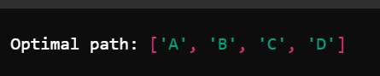

**9. Complexity Analysis**

The complexity of the pathfinding algorithm for real-time traffic navigation is a critical aspect when designing systems that adapt to dynamic conditions. The primary operations of the algorithm—searching for the shortest path and recalculating routes when traffic conditions change—are influenced by several factors:

1. Time Complexity:
   * Dijkstra’s Algorithm: For a graph with VVV vertices and EEE edges, the time complexity is O((V+E)log⁡V)O((V + E) \log V)O((V+E)logV) when using a priority queue (min-heap). In real-time traffic systems, the graph can be dynamic, with frequent updates to edge weights (representing traffic conditions). Recomputing the shortest path in real-time thus involves constant re-evaluation of the graph, which may increase the number of iterations.
   * *A Algorithm*\*: Similar to Dijkstra, but with the added complexity of a heuristic function. The time complexity is influenced by the quality of the heuristic. If the heuristic is well-designed (e.g., based on real-time traffic prediction), A* can outperform Dijkstra, but in the worst case, it can approach O((V+E)log⁡V)O((V + E) \log V)O((V+E)logV).
2. Space Complexity:
   * Both algorithms require storing the graph’s adjacency list and additional structures like priority queues and path tracking tables. This results in a space complexity of O(V+E)O(V + E)O(V+E) for Dijkstra and A*.
3. Dynamic Updates:
   * Real-time updates in traffic conditions introduce additional overhead. Recalculating paths as road conditions change might require algorithms

**8**

with lower update complexity (e.g., dynamic shortest-path algorithms) to maintain responsiveness. This could involve recalculating only parts of the graph that have changed, reducing the time complexity compared to recalculating the entire route.

1. Scalability:
   * As the network size (e.g., urban road networks) and data inputs (e.g., traffic sensors, GPS data) grow, the system needs to handle a large number of updates per second, requiring efficient data structures and possibly parallel computation.

**10.Conclusion**

The implementation of efficient pathfinding algorithms for real-time traffic navigation, such as Dijkstra and A*, combined with dynamic traffic data inputs, holds great promise for improving travel efficiency in urban areas. These algorithms ensure that drivers are provided with optimal routes, adapting to constantly changing conditions such as traffic jams, road closures, and accidents. The system’s ability to reroute based on real-time data reduces congestion, minimizes travel time, and enhances the overall driving experience. However, challenges remain in balancing algorithmic complexity with system responsiveness, especially in highly dynamic environments with large amounts of data.

Ultimately, the proposed system offers a practical approach to real-time traffic navigation, benefiting both drivers and urban traffic management authorities. Its adaptability and efficiency can lead to more sustainable and efficient urban mobility.

**11. Future Work**

Future improvements to the pathfinding system could focus on several key areas:

1. Predictive Traffic Modeling:
   * Integrating machine learning models to predict traffic patterns based on historical data and current traffic conditions could help improve route planning. Predictive models would allow the system to foresee traffic buildups before they occur, optimizing routes ahead of time and enhancing the user experience.
2. Personalized Route Optimization:
   * Future systems could incorporate user-specific preferences, such as avoiding toll roads, taking scenic routes, or minimizing the total time rather than just the shortest path. By learning from driving habits, the system could provide tailored route suggestions based on the individual’s past behavior.

**9**

1. Integration with Autonomous Vehicles:
   * As autonomous vehicles become more common, integrating pathfinding systems with vehicle control systems could further improve navigation efficiency. The algorithm could directly control route execution, adjusting routes without human intervention in real-time.
2. Scalability and Edge Computing:
   * As urban areas grow, the system’s scalability will become increasingly important. Edge computing, where data processing occurs closer to the source (e.g., on local traffic management devices), could reduce latency and improve response times.
3. Multi-modal Transportation Systems:
   * Future work could also explore multi-modal transportation systems, where the algorithm not only considers roads but integrates data from public transport, bicycles, and other forms of transit to provide a comprehensive navigation solution.

By pursuing these avenues, the system could evolve to meet the growing demand for smarter, more efficient transportation networks.

**10**